Gomolemo Ramokgola
ST10492431

Research done on my Mothers2Mothers project

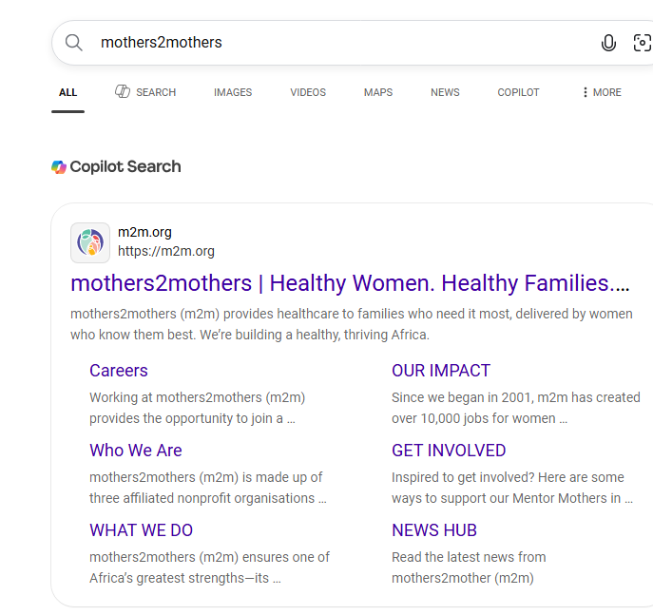

1. Website Purpose
The website is for Mother to Mother, a non-profit organisation in Atteridgeville. The goal is to help new mothers find support, join mentorship programmes, and access resources. The website must work well on phones because most mothers in our community use mobile data.

2. Target Audience
- Primary users: New mothers aged 18-35 living in Pretoria areas
- Secondary users: Volunteers wanting to become mentors, donors
- Needs: Easy to read, fast to load, clear buttons to download forms and contact us

3. Inspiration Websites
I looked at 2 South African NGO websites for ideas:

1. Cotlands.org.za
What I liked: Big clear images of children, simple menu with 5 pages, blue and white colors feel trustworthy.
What I’ll use: Keep my navigation to 5 pages only. Use photos of real mothers.

2. GiftOfTheGivers.org
What I liked: ‘Donate’ and ‘Volunteer’ buttons are very big and at the top. Easy to find help.
What I’ll use: Put my ‘Download Volunteer Form’ and ‘Contact Us’ buttons in the content section where users can see them fast.
And took inspiration from the actual M2m website
4.Layout Planning
The site uses the same structure on all pages for consistency:
1. Header: Logo on left, navigation menu on right
2. Content section: Heading, short paragraph, image, then call-to-action like download button
3. Footer: Copyright only

I chose this because WED5020 requires header, content, and footer. Users know where to look.

5. Colour and Font Choices
- Colours: Soft pink #F8C8DC and calm blue #6CA0DC. These feel caring and supportive, not corporate. Good for a mother-focused organisation.
- Fonts: Arial or similar sans-serif. It’s easy to read on cheap phones and loads fast. No fancy fonts needed.

6. Mobile-First Decision
Most mothers in Atteridgeville access internet on phones using data. So I will:
- Keep images small in file size
- Use short paragraphs
- Make buttons big enough to tap with a thumb

7. Content Decisions
I included PDF downloads because many users don’t have data to stay on the site long. They can download a form once and fill it offline. Each page has 1-2 PDFs related to that topic only.

Conclusion: The website is planned to be simple, caring, and easy to use on mobile phones/Pc’s so new mothers can get help quickly.
My compiling of the Missio,vision,goals is also clearly stated in the proposal submitted

